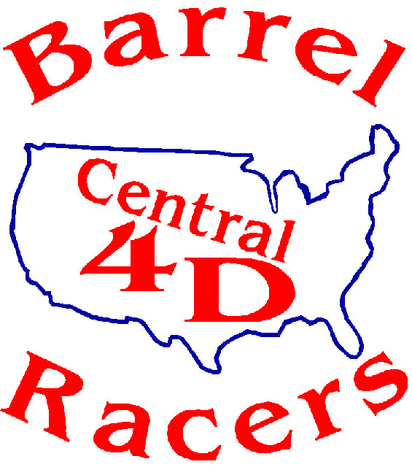
SPONSORSHIP FORM
The Central 4 D is a not-for-profit barrel racing organization spanning 28 years. We are a membership- based organization of roughly 150 to 200 members. Each year we put on a minimum of 12 races affording each rider to earn year end points accumulated to the year-end finals. Every dollar made through these efforts is in turn put back into the races through facility fees, rentals and year end awards. Every sponsorship goes to support year end awards consisting of saddles and other nice awards as well as to added monies for the races. Sponsorship banners are 3X6 in size. Your sponsorship is greatly appreciated! We are providing the sponsorship levels below and hope that you find a good fit. We appreciate your consideration.
Sponsorship Opportunities (16 events for 2025)
New Banner Sponsor ($350) Date___________________________ $________
Your banner will be hung in the arena for every event in 2025. Your company or organization will be recognized multiple times throughout events as well as on social media. Banner can be returned to sponsor after years events. Once a banner has been obtained, you are eligible to re-new your sponsorship for another year for $300.00.

Banner Sponsor Silver ($550-$1000) Date_____________________ $________
Your banner will be hung in the arena for every event in 2025. Your company or organization will be recognized multiple times throughout the event as well as on all Central 4 D social media pages. Includes added money and or product for a race specified by sponsor. If providing product, please specify qty and description of product.

Youth Banner Sponsor Date_________________________ $____________
Youth sponsorship funds will go towards youth and novice awards and year end jackets. Recognition multiple times throughout the event as well as on all Central 4 D social media pages. If a banner is desired, the minimum sponsorship is $350. After the year if you wish, your banner will be returned to you. If you wish to re-new your next year’s sponsorship will be $300.00.

Date___________________________ $________________________
Specific Sponsorship of any amount of funds for your choice of application, added monies, youth awards, senior award or open awards will be announced at all races; recognized on our social media page. Can be from $50 to $1000.00

Banner Sponsor Gold Saddle ($2500) Date____________________ $________
Your banner will be hung in the arena for every event in 2025. Recognition multiple times throughout the event as well as on all Central 4 D social media pages. Includes added money for a race or races specified by sponsor. Your logo will go on one of our year end award saddles.
Saddle sponsorship: $2500.00 Monies go to purchase year end saddles which will display your company logo as well as added monies for races and year end individual awards. If you are not already a banner sponsor, we will make you a 3X6 banner to hang in the arena at all races, we will advertise on our social media as well. At the end of the year if you do not wish to re-new your sponsorship, your banner will be returned to you.
Central 4 D 2025 Race Schedule
December 28th and 29th Co-Sanction Next Level Productions Chickasha Ok. (points)
January 25th and 26th Crossbar Arena Keifer Ok (points)
February 22nd and 23rd Purcell Indoor Arena pending confirmation (points)
Mar 8th and 9th Running R Indoor Arena Jacktown, Ok (points)
May 10th and 11th Crossbar Arena Keifer Ok (points)
June 7th and 8th Meeker Roundup Club (Points)
June 21st Meeker Roundup Club (Points weather make up race)
June 28th and 29th Running R Indoor Arena (points)
July 19th Location TBD (points)
Sept 12-14th Finals Location TBD (Fri night point)
Money Maker Races
November 16th OK Corral Indoor Arena
December 14^{th or 15th} Location TBD
January 11th Location TBD
February 15th or 16th Location TBD
The Central 4D Barrel Racers thank you for your support.
I have read and understand the terms & conditions with this form and wish to become a sponsor for Central 4D for 2025. I am enclosing payment for a total of $______ for the item selected above. (Please enclose a business card of your logo OR send a JPEG document to central4dbarrelracers@gmail.com
Signature__________________________________________ Date___/___/___.
CONTACT DETAILS
Organization name _____________________________________________________________
Contact Person ________________________________________________________________
Email ____________________________________ Telephone ___________________
Address _______________________________________________
City _______________ State _____ Zip code__________________
Website ______________________________________________
Mail signed sponsorship form to
Central 4 D Barrel Racers
P.O. Box 323
Newalla, Ok. 74857
Contact Ta’mara Ross with any questions.
Ta’mara Ross 405 308-7044

